Author: Mahesh Santosh bhakare

Employee ID: API2309

Batch: Greenfiled Training Batch 31

Title: 1. Maven Project to Connect with database.

**Source Code:**

pom.xml

<project xmlns=*"http://maven.apache.org/POM/4.0.0"* xmlns:xsi=*"http://www.w3.org/2001/XMLSchema-instance"* xsi:schemaLocation=*"http://maven.apache.org/POM/4.0.0 https://maven.apache.org/xsd/maven-4.0.0.xsd"*>

<modelVersion>4.0.0</modelVersion>

<groupId>com.apisero.greenfield</groupId>

<artifactId>JDBCConnection</artifactId>

<version>0.0.1-SNAPSHOT</version>

<dependencies>

<!-- https://mvnrepository.com/artifact/mysql/mysql-connector-java -->

<dependency>

<groupId>mysql</groupId>

<artifactId>mysql-connector-java</artifactId>

<version>8.0.26</version>

</dependency>

</dependencies>

</project>

JDBCConnection.java

**package** com.apisero.greenfield;

**import** java.sql.*;

**public** **class** JDBCConnection {

**public** **static** **void** main(String[] args) {

Connection con = **null**;

ResultSet rs = **null**;

**try** {

con = DriverManager.*getConnection*("jdbc:mysql://localhost:3306/Batch31", "mahesh", "mahesh12@");

PreparedStatement ps = con.prepareStatement("select * from Student;");

rs = ps.executeQuery();

**while** (rs.next()) {

System.***out***.println(

"Roll No.: " + rs.getInt(1) + " | Name: " + rs.getString(2) + " | Marks: " + rs.getFloat(3));

}

} **catch** (SQLException e) {

e.printStackTrace();

} **finally** {

**try** {

rs.close();

con.close();

} **catch** (Exception e) {

e.printStackTrace();

}

}

}

}

**Output:**

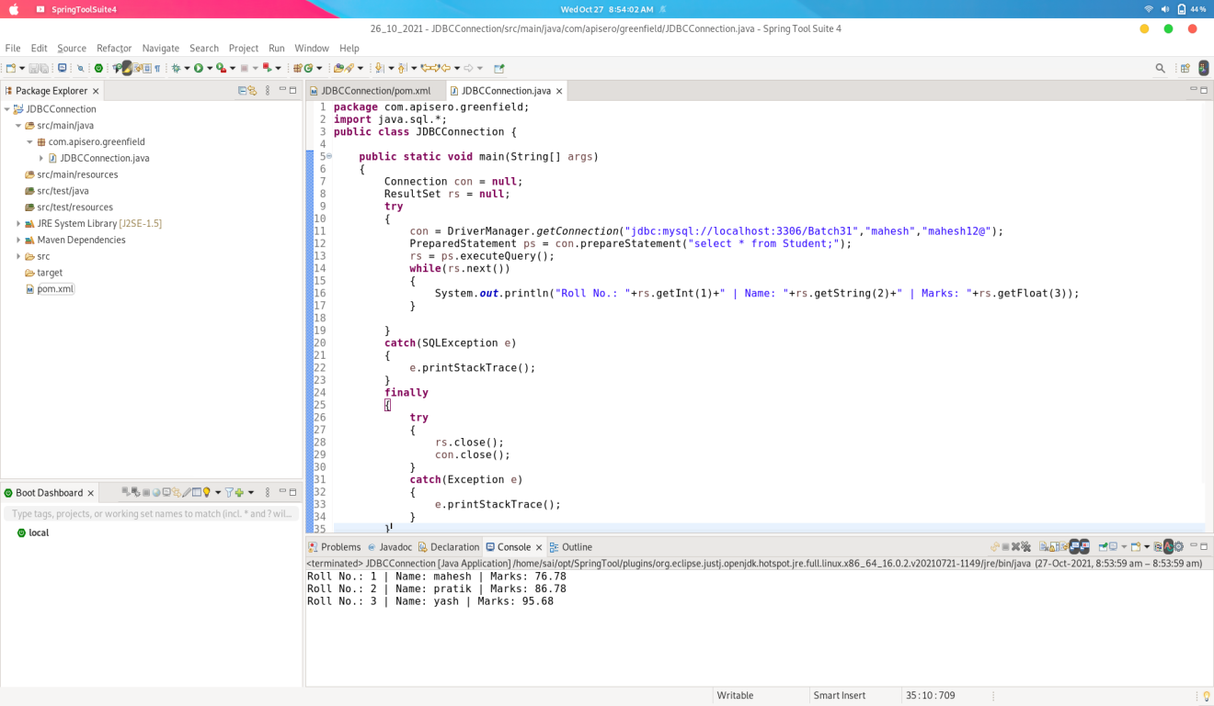

Title: 2. Use jenkins tool to compile and run java application from Git Repo (Use Job and Pipeline).

**Steps:**

1. Create new Job using pipeline

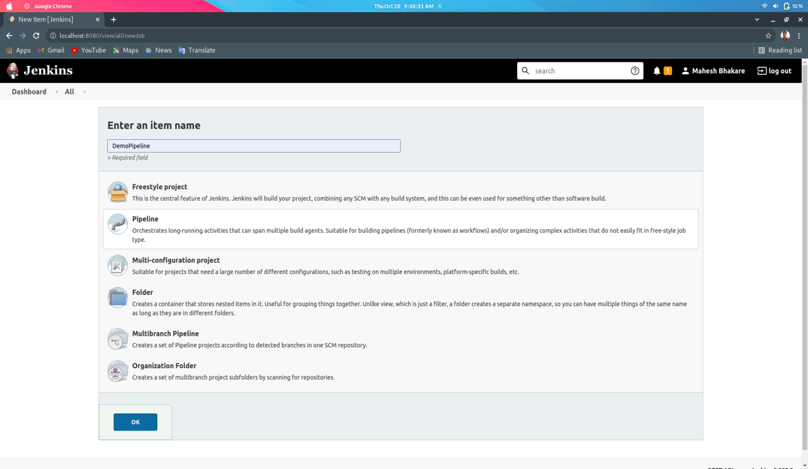

1. Configuring the Job.

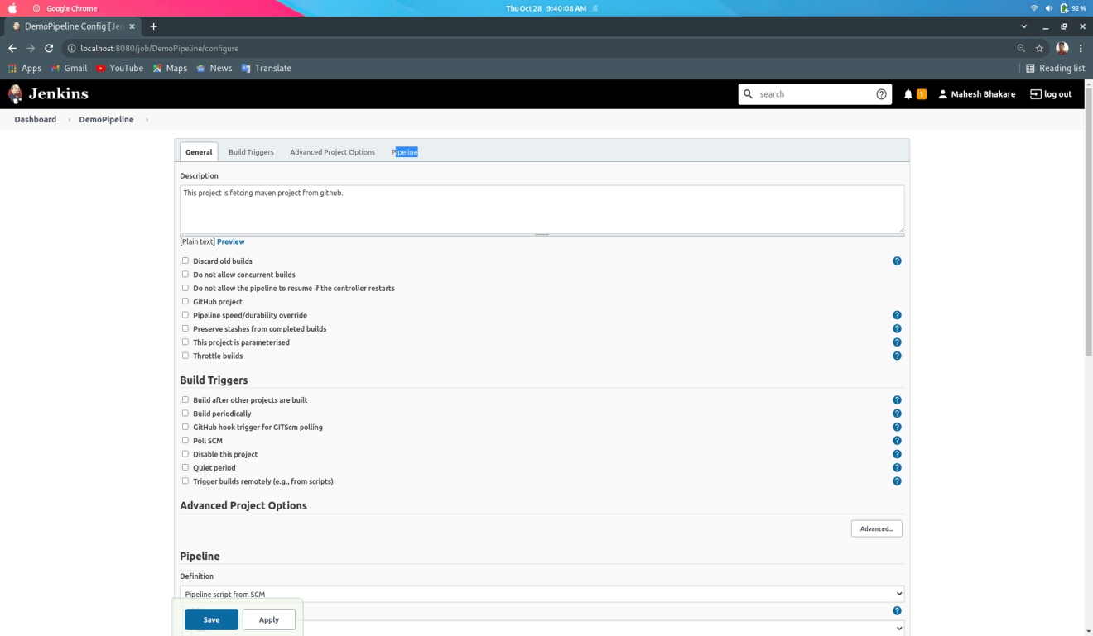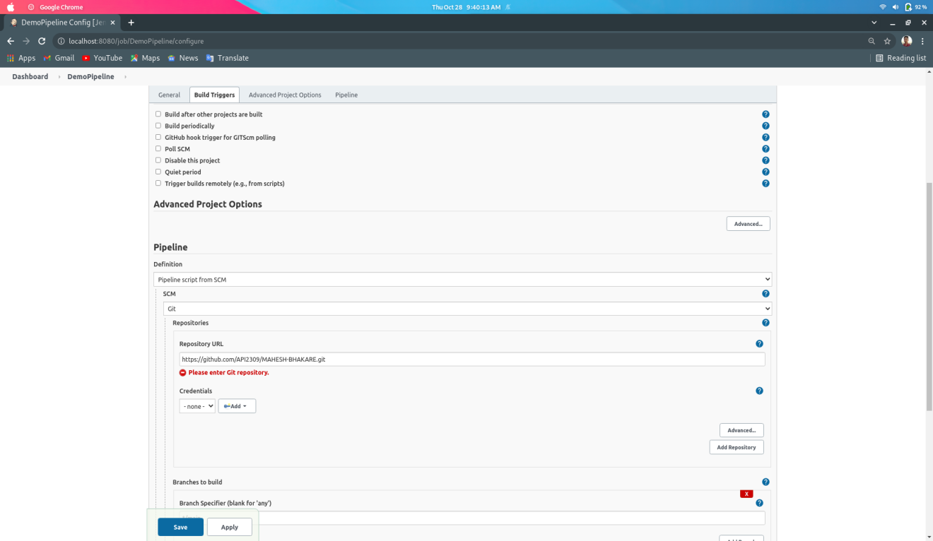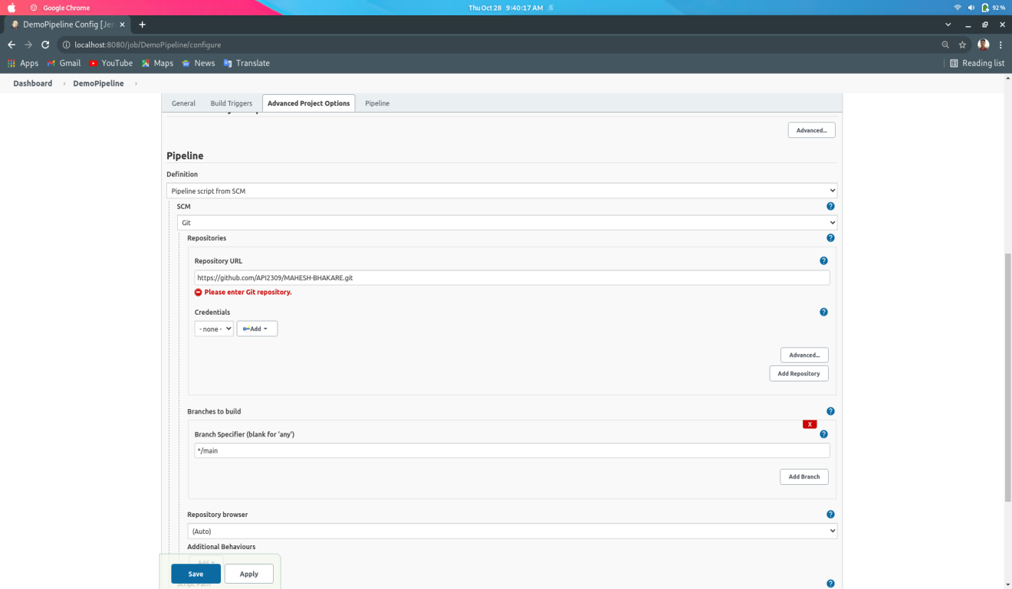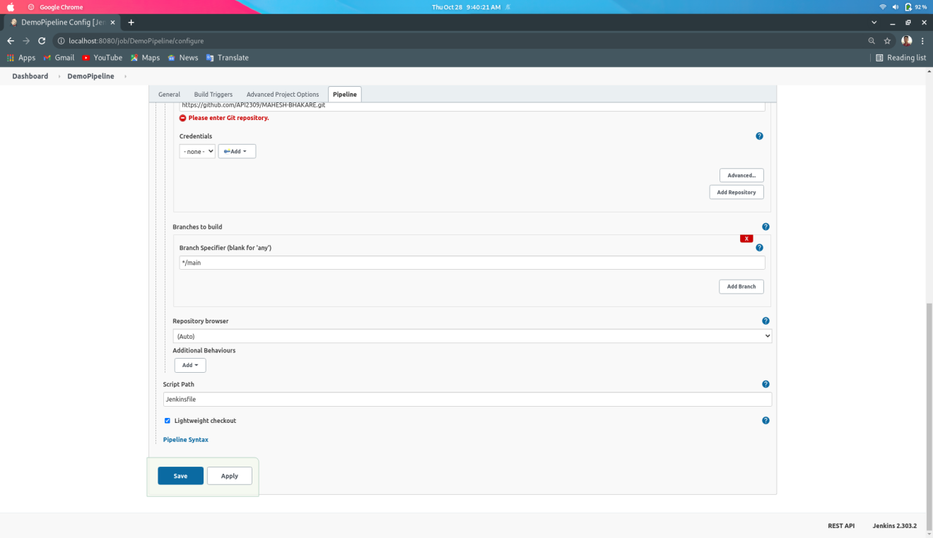

1. Git repository where maven project present.

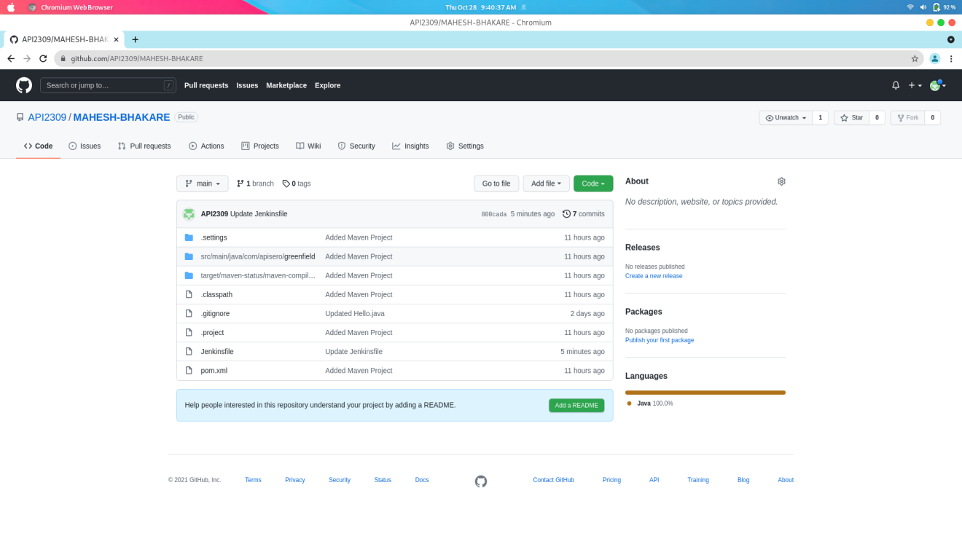

1. Output after Build the project.

